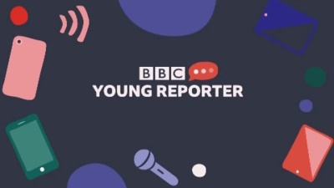
Ysgol Coedcae School
Young Reporter 2020

Pupils at Ysgol Coedcae School took part in the BBC School News Report Day on Tuesday 10th March 2020.

They spent the day as journalists where they researched news stories, wrote scripts, filmed and edited podcasts, and wrote their stories into articles.

This magazine has been compiled to showcase the work they accomplished throughout the day.

The video news bulletins they recorded are available on Coedcae’s BBC Young Reporter YouTube channel and can be accessed via the ‘School life’ link on the Coedcae’s website.
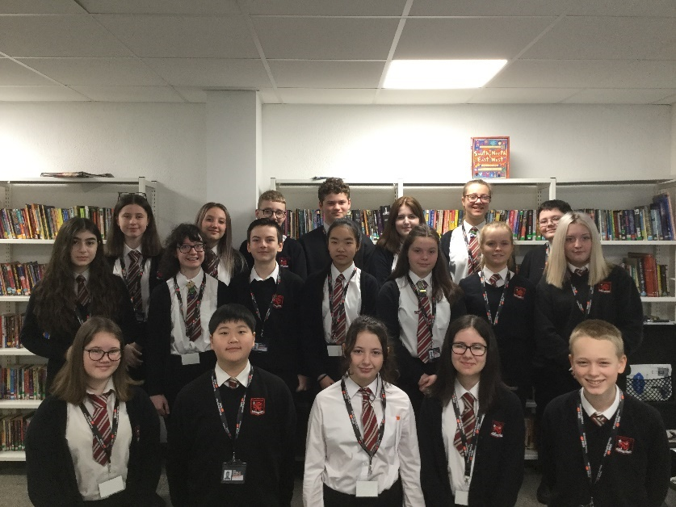

Here are the pupils who took park in the BBC Young Reporter Day:

Chloe
Rhys T
Lily
Matilda
Ceren
Ela
Rhys L
Keira
Seowan
Freddie
Finley
Joseph
Eliza
Lola
Eva
Joo-Young
Ellie
Ayame

Homelessness in the U.K

By Finley

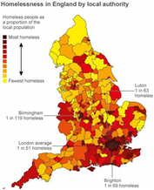
Homelessness in Britain is a constant concern for the government as it seems this issue is not going away. Our country has a legal duty to help all those suffering from homelessness and each country in Britain, Wales, England, Scotland, and Northern Ireland, has a slightly different way of solving the problem. With ideas of having a singular organisation to help tackle the problem, like Northern Ireland has done with Council for the Homeless Northern Irish.

How do people become homeless? We’ve all seen people living in the street but how did they get there? Well it's because of social causes of homelessness, such as a lack of affordable housing, poverty and unemployment; also, life events which cause individuals to become homeless. People also can become homeless when they leave prison, care or the army with no home to go to.
At least 320,000 people are homeless in U.K according to research by the housing charity “Shelter”. This amounts to a year-on-year increase of 13,000. That’s a 4% rise each year and its bound to get worse, despite government pledges to tackle the crisis. The estimate suggests that, nationally, one in 200 people are currently homeless in our supposedly first world country.

Also, with the rising numbers, that leaves more people to homeless abusive where everyday people, violently attack homeless people. People sleeping on the street are almost 17 times more likely to have been victims of violence. More than one in three people sleeping rough have been deliberately hit, kicked or experienced some other form of violence whilst homeless. Because of these attacks the homeless are left with permanent scars and the average life span of a long-time homeless person is just 44 years.
This is terrible, something must be done. Donate to charities like the one I mentioned, Shelter. Shelter is an organisation which gets donations from the general public to help tackle this pressing issue and support people living in the streets with their needs.
Shelter

Should School Curriculums be Altered?

By Ayame, Jasmine and Ceren

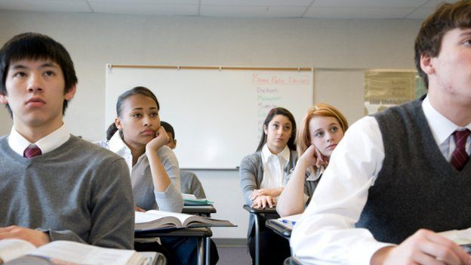
By discussing this question (Should School curriculums be altered?), we have discovered that primary schools don’t teach all topics to the same extent as others. This could certainly impact how pupils perform in certain subjects when going into comprehensive school. A student could not have done a lot of the core subjects (for example science) in Primary school which could cause them to be in a lower set than other lessons as they had not had the opportunity to do so well in those subjects. This could then lead them to have a hard time finding a good collage as they were in the lower classes which then could lead to having a bad job as you need English, Mathematics and Science (also Welsh if you live in Wales) to get a good job.

We interviewed Coedcae science teacher, Mrs. Morgan, and she said...

“I believe that secondary schools should eb teaching pupils more modern subjects that are relevant in society.” She mentioned that “in science, year 11s will be learning about crude oil, however I think that they should have more lessons on recycling and how to help the environment in order to make them aware of everything inside the modern world. This will prepare students for life outside school and the ‘real world’ where there are many problems that could be fixed through education inside schools.”

On the topic of Year 11 and GCSEs, we believe that the option blocks for GCSEs should have a wider range of subjects so pupils are able to choose the subjects that they enjoy and do well in, not taking a subject just because the range does not suit the subjects they wanted to take. This could cause the pupil to fail the most important exams of their entire life, just because they were not able to choose the subject they wanted to do. As we said earlier, this would lead them to get a bad job as the good collages look for people with all their GCSEs not just some.

Will we ever achieve true equality?

By Ela, Keira, Rhys L and Seowan
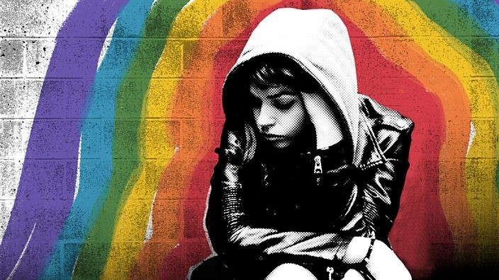
Britain that country that we all love, the heart of freedom and equality... or is it. We have a problem in this country, in fact we have many issues but four of the main ones are racism, religious prejudice, lack gender equality and homophobia. Ethnic minorities are three times as likely to be thrown out of bars, clubs or restaurants or just simply denied entrance in the last five years and more than two thirds believe that Britain has a problem with racism. The music industry is guilty of racism. Music videos online get millions and millions of views. YouTube doesn’t seem to have a problem with racism... right? Well just a couple of weeks ago a famous K-pop band got millions of views and deleted! How can we allow innocent people who are just like us to be persecuted? The simple answer is we can’t, if we come together as a country and a community then we can combat the huge injustice of racism.

Then we have the purely unbelievable occurrence of homophobia, in a day and age when everyone is so diverse and accepting how are slurs right from the middle ages. Pride, a celebration of everything happy and different, is being disturbed by protesters claiming the ’carry the word of god’. Children younger than 13 are attempting suicide over terrible homophobic bullying. We are killing children through poor education.

Let’s not even begin to mention the lack of gender equality and the giant gender pay gap scandal. We were all shocked by the pay gap that was discovered in the television and once again the music industry. Women doing the exact same job as men were payed thousands less! The exact same job! What reason does the industry have for this?

Then finally we have the religious prejudice, we discovered a shocking statistic. Muslim men are 76% less likely to get a job than a Christian man. Tell me what impact religion has on a person's ability to be an architect or doctor or even a builder. We must come together and stand up to those who hurt others for absolutely no reason.

Drama is or isn’t important for a child's curriculum?

By Chloe

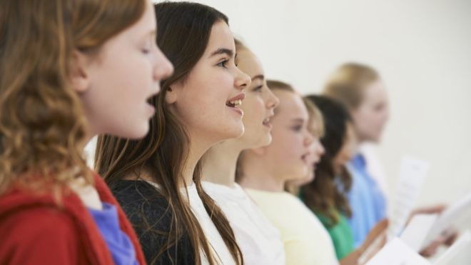
Why don’t we learn drama at school, why don’t we do taxes in math's? Some of the subjects in our schools aren’t needed for future, doctors or politicians, were as taxed and business studies are, however drama can teach you creativity, confidence and self-expression. Any of these skills can help with future jobs even if it isn’t acting itself, you need confidence to be a politician, you need creativity to think of new laws to keep us safe. As you can see without drama, we wouldn’t have any of the new laws today. Drama is an effective learning tool because it needs a student's intellectual, physical, social and emotional skills, to act out and create new plays/ pantomimes.

For GCSE’s Geography, History, French, and Spanish have had a clear increase in popularity increase since its introduction. Furthermore, Spanish is within the category of the most average GCSE’s passed. Spanish has a passing grade of on average 90%. Not only having a passing grade of on average 90% it is also in the category of some of the easiest GCSE’s.

Drama however is in the category for some of the more difficult GCSE’s, even though it can be difficult, as you can see also has its positives. Spanish is easier than Drama so is studied earlier however if Drama was studied from a younger age perhaps, they could have some of the more beneficial skills and children wouldn’t be afraid to take it for GCSE’s.

Has Equality Had An Impact?

By Rhys Thomas

Equality, we all want and need it. Has pay been distributed by work ethic and hard work, or has it been distributed by gender? We all want it, but it might be hard to get. I am here to discuss if equality has had an impact on workplaces, or if it has just faded away and pay is being distributed by gender.

Equality was introduced in 2010. Both genders came together to introduce 116 separate pieces of legislation into one act. But, has this act had an impact on the workplace? According to The Bureau of Labor Statistics, in 2013 full-time female workers were paid $706, compared to the male full-time workers, they were paid $860, a $154 difference between them. This shows that the 3-year span, equality had made a slight difference, but it still affected women.

But, in 2015, in the UK a woman, on average would earn 80p, for every £1 made by a man. 20p may seem like a small difference but think about that over the course of 1 day. Say a man was paid £100 per hour, and he worked 5 hours, he would earn £500, where as a female would be paid £400! That £100 could get you the bare essentials. But, it might not just be women who are being underpaid, a male could be equally as underpaid as a woman.

However, there are companies who have matched their pay for their workers. Or even based it off who works the hardest and who has the most commitment to their job. I interviewed Mr. Bevan, a teacher at Coedcae Comprehensive School about this topic and he said this. “I believe pay should be based upon competence, experience and ability, not gender. I believe identifying gender, as a reason to pay more or less is unreasonable and also incredibly unfair.” I agree with him because nobody should be judged upon their gender and paid because they are male or female. A female could be hardworking and be paid less, same for a male. We need to make sure that pay is based upon competence, experience and ability, not gender.

I think that there has been a difference when equality has been introduced. But some companies are still basing it off gender, and that is rude. I hope one day that this will change and every company will follow the gender equality act. We need to make sure that companies are basing it off ability and how loyal they are to their job.

What is DID?

By Lola and Joo-Young

DID is short for Dissociative Identity Disorder. It is when a person has multiple personalities and often switches between them. There is a host that fronts most of the time, this is normally the person who was born into the body. However, the host may change depending on the situations.
Also, 90% of confirmed cases of DID are caused by a history of childhood abuse, the other cases show that the body or mind has experienced many health problems during pre-adolescent years. The main causes of DID are: Emotional, Physical or Sexual Abuse, Accidents, Natural Disasters, War, Loss of Loved Ones and Trauma in Early Childhood.
The disorder massively affects life for the victim as they normally have little to none control. The alters tend to have their own names and ages, some even have roles within the system.

The 2 main roles:
The host:
- The host is the alter that fronts (controls) the body the most. In most cases, the host is the personality/alter that was born into the body.
The primary protector:
- The primary protector is the alter that has been with the original host for the majority of their life. They were most likely the first alter to appear. They act as a conscience or in-head friend that promises to protect you and give you advice.

What are the symptoms?
There are quite a number of symptoms of DID, the most common symptoms are:
- Feeling stranger to yourself,
- Feeling as though different people are within you - voices that may not sound like yourself or your conscience, possibly with a different accent or tone/pitch,
- Behaving out of character – this may include speaking with different vocabulary, accents or behaving in a different manner,
- Writing in different handwriting &
- Small durations of amnesia (short spurts of memory loss).

Unfortunately, not many people are aware of this disorder. It is more commonly known as multiple identity disorder. The media hasn’t advertised this, the one film that portrays a DID system is the 2016 film “Split”.
Some aspects of the film are accurate, such as the switching amnesia and lack of control. Also, the fact that they show some different roles like the protector and child alters (littles) is somewhat accurate. However, it makes the DID community appear dangerous with the involvement of the “Beast” character. People with DID are actually more likely to revert back into the victim state rather than abuser.
There are many different ways that DID is portrayed however, most assumptions tend to be incorrect. People with DID aren’t vicious or insane. They are the same as us but with more personalities.

Now is the time to end violence against animals

By Ellie and Eva
Would you ever hit a loved one to the point that they are bleeding? Would you ever mentally scar a loved one? The majority would say no, but for a small handful they could or do take part in this kind of behavior most days and its commonly on animals. Pets usually suffer the first few blows from the abuser who later may go on to hit family members or loved ones, but why is animal abuse considered less of a problem than abuse to humans? Animals breathe, feel, think, hear and love just as much as humans do and they do nothing wrong. There are so many inhumane torture methods used on animals, one disgusting example would be horse slaughter. The innocent animals have a ‘fight or flight’ nature meaning that they get hit more than once with a weapon. Some horses are even conscious while being dismembered for their meat which is very unhealthy for humans anyway due to the unknown past of the horse. They are shipped like cargo for over 24 hours without food or water. Some interpret their fate and die of shock or terror. Another awful form of animal abuse is animal mills or most common puppy and kitten mills. Animals are confined in tiny cages in their own waste and made to give birth to as many puppies or kittens as possible for the rest of their lives until they die. For animals, giving birth too many times can cause long term health problems. Some mills may even not clean out the carcasses from the place they are kept. If you are ever looking for a family pet it is encouraged to buy from a trusted breeder who is happy to show where the puppies or kittens were born, who the parents are and are overall happy to see you. Even better would be to get a rescue animal, they have been through unimaginable terror, abuse or abandonment and are always able to learn to love again. Another form of animal cruelty is animal hoarding. The person hoarding the animal may genuinely think that they are doing the animal good. The animal hoarders usually rescue a lot of animals from shelters feeling as if they have done a good deed but, they are making the animals suffer. Not a lot of the animals they are hoarding are spayed meaning the animals can reproduce and the owner may not be aware of the new offspring. Sometimes there are so many animals in the house that they are living in their own waste. In extreme cases the owner will not know if any animals have died leaving carcasses on the floors. Most of the time, hoarding of animals is due to a mental illness who then have the animals taken away and get treated for their disorders. The inhumane acts of unconsensual testing are used on a variety of different animals like; cats, dogs, rabbits, guinea pigs, hamsters, farm animals, fish, mini-pigs and non-human primates. Different tests on these animals include things like; forced chemical exposure, exposure to drugs, genetic manipulation, ear-notching and tail-clipping for identification, physical restraint for periods of time, food and water deprivation, surgical procedures, killing by carbon-dioxide, neck-breaking, suffocation, decapitation, infliction of pain and wounds, behavorial experiments and much more. We need to stand up to animal abuse.

Who is to blame for Climate Change?
By Lily
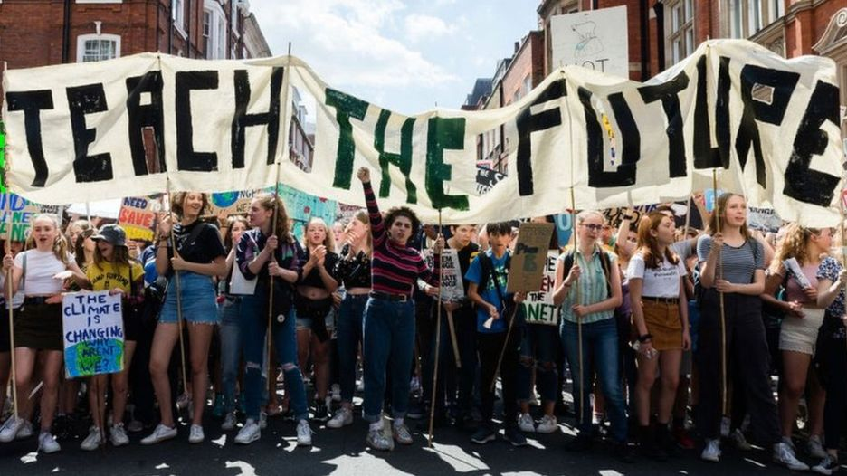
It’s pretty safe to say that Climate change is real and a problem, no matter what anybody else is saying. We need to act now, saying that we are going to be doing this and that in the near future is simply not good enough, we need change, a climate change. We may already be too late but those of you out there that say that there is no point in trying is mistaken. There is always a point in trying to better our mistakes. We have caused this Earth so much damage already. We are the reason we may not be here in the 30 years. It is our fault. So, don’t go blaming the politicians, your next-door neighbour because it is your fault, as it is mine too. We can’t change what we have done in the past and dwell on it; we need to look the future. If we carry on the way we want to live instead of the way we need to live then you what are you teaching your children, your younger siblings? To only care about ourselves and not care about this will affect everyone else around us. Now, I’m not saying that we need to start living off where the sun is or how fast the wind is blowing but small changes can make a big difference. I know that it sounds very cliché but it’s true, instead of simply throwing waste in the right bag or picking up that sweet wrapper on the floor will go a long way. Or just spreading the news of climate change like I’m doing now, even if only three people change even the tiniest thing that they do is, as I say “better than nothing”. Ice is melting, which then contributes to sea-level rise causing floods. Rising temperatures are affecting wildlife and their habitats. As temperatures change, many species could possibly go extinct. Do you want that to happen? So, please think about what you are doing to yourselves and the others around you, the beautiful wildlife, the animals of all shapes and sizes. Stop climate change to make a better tommorow. #No time to waste

Will Rats be Eraticated?
By Eliza and Joseph
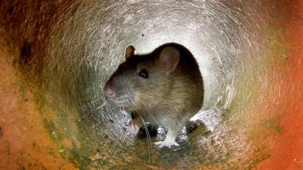
With an estimated 1.5 billion rats in the U.K alone, it seems as though our rodents are here to stay. However, with more pest companies taking further action against rats and an increase in them spreading diseases, their days could be numbered. Also, it is looking more likely that giant rats will make a comeback after they became extinct during the Jurassic period.
Rats are well-known for their fierce bites, but last year 120 million people contracted rat-related diseases through their bites. They will attack babies, invalids and the elderly even when they are completely unprovoked. They are also adept at breaking into people’s homes and making nests in people’s back garden. This can cause houses being overrun with rodents. Consequently, some people believe that rats should be culled. Millions of pounds’ worth of livestock is lost each year to farmers, so they believe that enough is enough. Local farmer George Roe said “I found rats in my farm the other day, it isn’t on. It isn’t fair on me or my animals”. Rats are also skilled at spreading diseases. Historically they have spread diseases such as the Plague and Rat Bite Fever, and in some cases, it could be fatal. It is impossible to locate and vaccinate all of the rats in the world as they are always moving and hiding. It would also be a hazard to the volunteers as they would get attacked or bitten.
Despite this, some people believe that rats aren’t doing that badly. If we were to cull them, then our ecosystems would collapse. We rely on rats to eat the excess insects and to control the insect population, but without them we would be overrun with rats. There would also be less pollen for the bees who are already in decline, so it would be an all round negative. With less bees, there would be less honey. Britain already has a thriving honey market, so it could impact our economy. The lip balm industry would also be in decline as bee’s wax is used in some lip balms, so the economy could potentially crash. It would also be inhumane to kill them as there are worse animals out there that affect the U.K in a worse way. There would also be the issue as to how to kill them and how we would ensure that we had targeted all of them. Animal rights activist Elizabeth Cory told us “It’s disgusting that we would even consider culling the rats. I don’t necessarily like them, but they are very sweet and they haven’t actually done anything wrong other than live”. Perhaps our NHS could also be faced with more pressure as we wouldn’t be able to make new medical breakthroughs if we can’t test on rats anymore. If they cease to exist, then we could be lacking essential cures.
Either way, it is a very controversial yet little known issue. Some people believe they should be exterminated, whereas others want them to stay. Whatever happens, this problem won’t be resolved anytime soon, and the issue of eRATication is here to stay.

